A New Social Network
Final Project Research

Filip Kolovrat
CIS 1020-037
04/14/2011

Contents
Introduction 2
Body 3
New Social Network 4
Bibliography 5

Introduction

The world we live in is full of media pollution and harmful material. It is an everyday struggle that everyone experiences at one point or another. Whether it is a kid being bullied at school, Facebook or MySpace, or a parent struggling to set their child on the right path to success, there are countless mediums from which children nowadays are forming jaded opinions toward life. Violence and vulgarity are being portrayed as being ok in everyday life because of books, magazines, music, and television and movies that advertise it nonchalantly. In a technology driven world, these sources are becoming more and more available to children, and the message that they are receiving from those sources is very destructive to their young minds that are still budding. Some parents can catch it early and do something about it, but most are not that lucky. If parents let this start, then it will grow and grow until they are completely unable to set their kids on a better course. The amount of media pollution is staggering, and the effects of it are very serious. Obesity and diabetes are increasing and starting younger and younger. Addictions to drugs, social networks, and other things are getting far too severe. Children experience very low self esteem and because of that, their grades go down and depression sets in. Websites like Facebook and MySpace are a big part of the low self esteem problem. Cyberbullying has become a relevant issue and kids start thinking that they are judged by the amount of “friends” they have on Facebook, which causes low self esteem for those who do not have many. Even parents are not immune to this, seeing as domestic violence and divorce rates have increased as well. I like to think of my body as a temple, and it is a priority to treat yourself with respect; but the negative media in our world validates the killing of our body, mind, spirit, and the relationships with the people that we love. It seems that people don’t even realize what they are doing to themselves and the people around them; this is a problem that has grown over many years and has become a plague to our society.

Body

Statistics:
- In the United States, it is estimated that 93 million Americans are obese. (Obesity Action Coalition, 2010)
- Almost 112,000 annual deaths are attributable to obesity. (Obesity Action Coalition, 2010)
- More than 9 million adolescents (children and teens 6 to 19 years old) are considered overweight. (Obesity Action Coalition, 2010)
- More than 40 percent of children watch 2 or more hours of television each day. (Obesity Action Coalition, 2010)
- The most occurring sign of discrimination among obese children is social and societal acceptance. This negative discrimination can lead to poor self-esteem and depression. (Obesity Action Coalition, 2010)
- Today, obese children are much more likely to develop type 2 diabetes more than ever. (Obesity Action Coalition, 2010)
- 1 out of 4 kids is bullied. (How to Stop Bullying, 2009)
- School bullying statistics surveys show that 77% of students are bullied mentally, verbally, or physically. Cyber bullying statistics are rapidly approaching similar numbers. (How to Stop Bullying, 2009)
- The average American youth spends 1500 hours (that’s over 2 months) per year watching TV. (CSUN, 2007)
- 73% of teens and young adults are a member of at least one social network. (Graphics.ms, 2010)
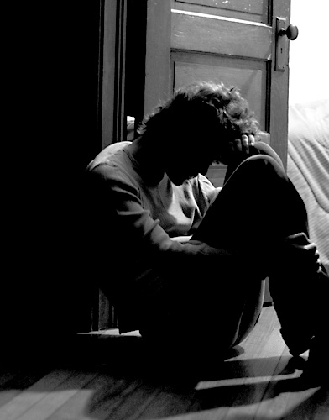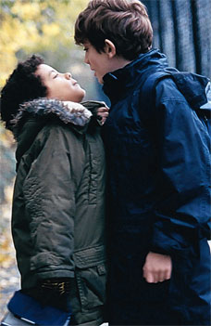

New Social Network
All of those reasons are why I am creating a new, better social network called “YOU.” It will be a network of kids, parents, and anyone else who wants to join and focus on bettering themselves. There will be no friend counter, which is the basis of focusing on the self. “YOU” will have many resources for teens and young adults such as professionals that can help with certain problems or questions. There will also be a portion of the site dedicated to education. This portion will include homework help for any age group or grade, study material, quizzes, and it will also include college scholarships that are available for students to look through and apply for right on the site. Offering college scholarships through a social network will hopefully give students more motivation to do well in school and strive to achieve good grades and receive scholarships.
The mission of this new and exciting site is to take the focus off of the number of “friends” you have. Sadly, there are many people on Facebook and other sites like it that don’t even know most of the people they are friends with, which shows that it is just a pointless popularity contest. “YOU” will instead put the spotlight on bettering yourself as a person and feeling better about yourself. This can be done in many different ways on the site. There are school and homework resources, scholarship and grant opportunities, self-help tips, and much more. The goal is to start within yourself. If everyone with low self-esteem joined the site and started improving, imagine the positive impact that they might have on others around them if they were more confident in themselves. That is what I hope to accomplish with this social network. It is free and easy to join, so there is nothing to lose by trying it out. You may be pleasantly surprised and maybe even learn something new about yourself. The sky is the limit.
So…
TELL YOUR FRIENDS AND FAMILY TO JOIN!!!

Bibliography

CSUN. (2007). Retrieved from Television and Health: http://www.csun.edu/science/health/docs/tv&health.html
Graphics.ms. (2010). Retrieved from Social Networking Statistics: http://www.graphicsms.com/blog/877-social-networking-statistics-2010/
How to Stop Bullying. (2009). Retrieved from Bullying Statistics: http://www.how-to-stop-bullying.com/bullyingstatistics.html
Obesity Action Coalition. (2010). Retrieved from Educational Tools: http://www.obesityaction.org/educationaltools/factsandstats.php

